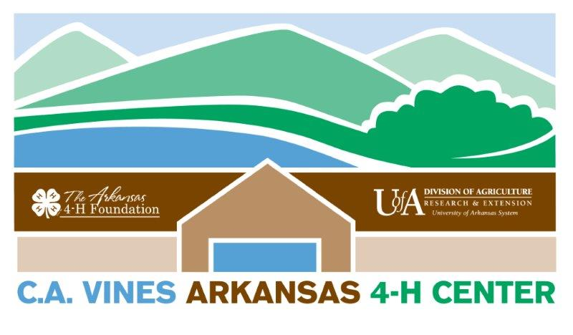 Conference Meeting Package Prices
Day Package | Single Occupancy Friday Night Only | Single Occupancy One Night | Single Occupancy Two Nights
$31.50 | $151.00 | $132.75 | $254.00
Lunch  Beverage Service  Meeting Space  AV Equipment | 3 Meals D BL  Lodging (Single Occupancy)  Beverage Service  Meeting Space  AV Equipment | 3 Meals D BL  Lodging (Single Occupancy)  Beverage Service  Meeting Space  AV Equipment | 5 Meals D BLD B  Lodging (Single Occupancy)  Beverage Service  Meeting Space  AV Equipment
Day Package | Double Occupancy Friday Night Only | Double Occupancy One Night | Double Occupancy Two Nights
$38.00 | $133.75 | $115.50 | $219.50
CB  Lunch  Beverage Service  Meeting Space  AV Equipment | 3 Meals D BL  Lodging (Average 2 or more to a room)  Beverage Service  Meeting Space  AV Equipment | 3 Meals D BL  Lodging (Average 2 or more to a room)  Beverage Service  Meeting Space  AV Equipment | 5 Meals D BLD B  Lodging (Average 2 or more to a room)  Beverage Service  Meeting Space  AV Equipment
 | Triple Occupancy Friday Night Only | Triple Occupancy One Night | Triple Occupancy Two Nights
 | $119.50 | $101.25 | $191.00
 | 3 Meals D BL  Lodging (Average 3 or more to a room)  Beverage Service  Meeting Space  AV Equipment | 3 Meals D BL  Lodging (Average 3 or more to a room)  Beverage Service  Meeting Space  AV Equipment | 5 Meals D BLD B  Lodging (Average 3 or more to a room)  Beverage Service  Meeting Space  AV Equipment
Other packages are available, please call 501- 821-4444.
Prices effective Jan 1-Dec 31, 2019.

